Create a file max-temp.txt in local FS.

Put some 10-15 records of date and temperature example

Crated file-max.txt in local with approximately 10 or 15 , please refer the below the screenshot.

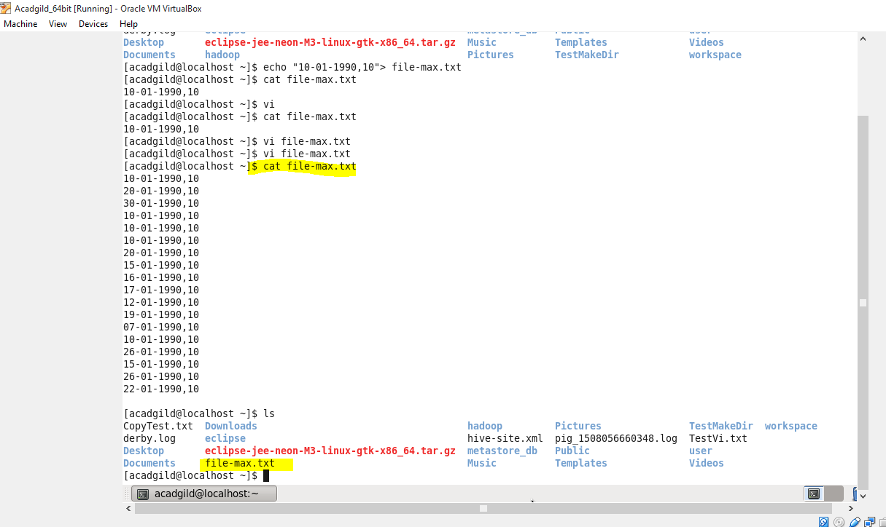

Instead of making directory HADOOP I created the Muni_directory and moved the file to this directory.

